**New Customer/Partner org Creation**

1. Go to “Environment Hub” tab in Rootstock CRM org.
2. Click on “Create Org” button
3. If you are creating a customer org please provide below details :

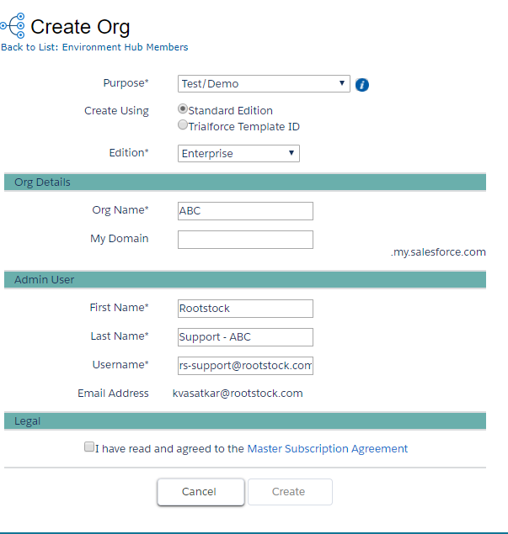

1. If you are creating an org for development purpose use below option:



1. When the org is created, please change its email field to [rs-support@rootstock.com](mailto:rs-support@rootstock.com).

To edit Rootstock Support User, Create a permission set "Edit Self-Service Users”

Permission Set >> create new >> “Edit Self-Service Users” >> licenses type >> “salesforce” >> App permissions >> Call Center >> check the "Manage Customer Users" checkbox >> assign to the RS-Support user.

1. After all these changes please provide Org ID to Nancy for salesforce licenses provisioning through SSO.